Duo Self Service Portal and Configuration Options

Important Information
The Duo Self Service Portal offers the ability to manage devices that can be used for authentication, and change authentication methods and other settings. This guide assumes that an authentication method has already been successfully configured for the account, which is required to follow the steps illustrated below.

Access CCCS Duo Self Service Portal
To access Duo Central, go to https://cccs.login.duosecurity.com using your preferred browser. The login window shown below will be displayed.
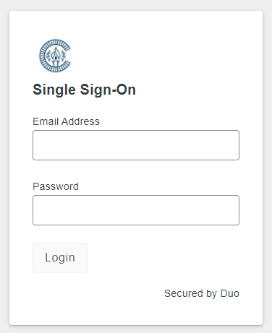
Login using your CCCS email address (firstname.lastname@cccs.edu) and your snumber password.
Once you have successfully logged in, you will see the authentication method selection page shown below. Do not select an authentication method yet. If a green authentication method button is selected, the chosen method will be activated and you will be taken to the CCCS Duo Central page which is currently under construction and is a dead end. Instead, you will select from the links below the CCCS logo.
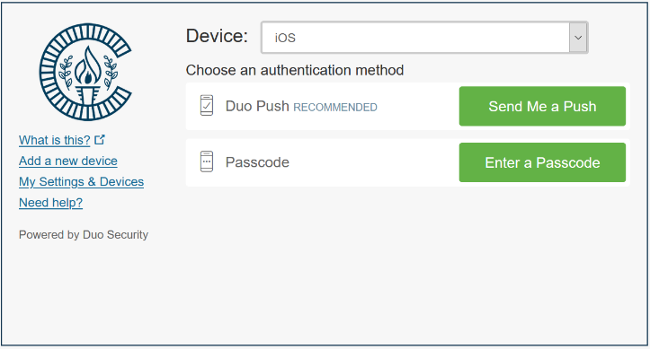

Adding a new device
To add a new device as a Duo authentication method, select “Add a new device” from the links under the CCCS logo.
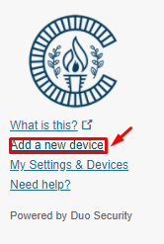
This will trigger an action to authenticate with the currently configured Duo authentication method (push notification or passcode entry). Choose an authentication method by clicking on the green button that matches your preference.
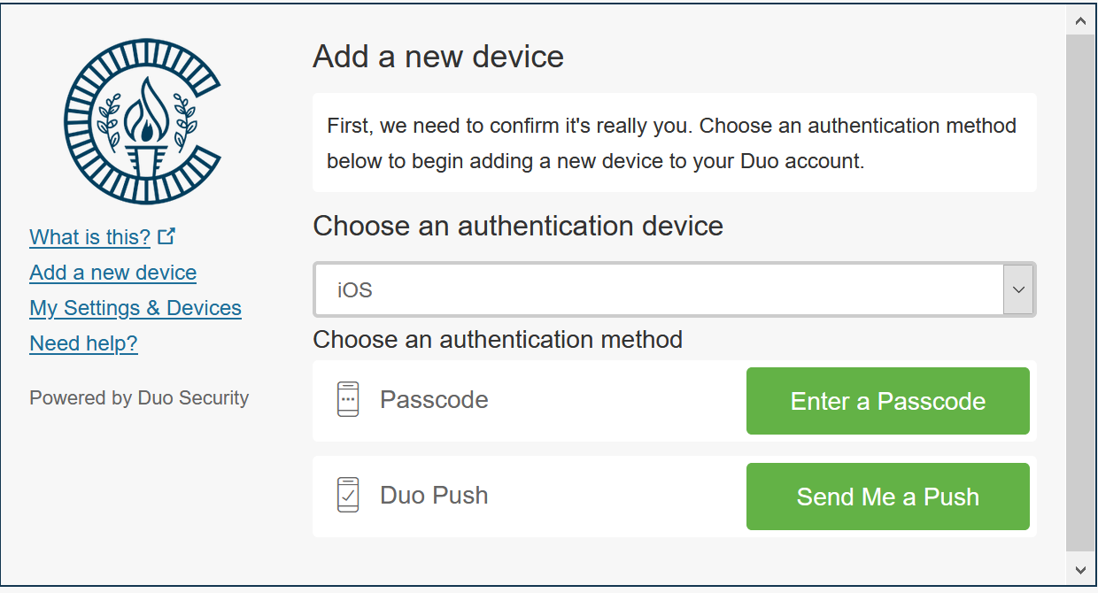
Once authenticated, you will be taken to the device selection page shown below.
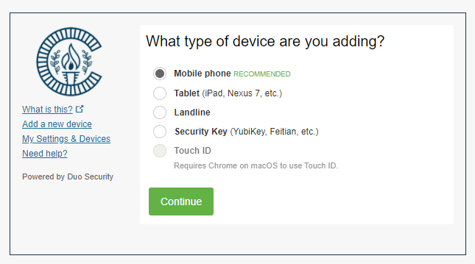
Here you will make the applicable selection for the new device you would like to add. Additional prompts will follow where you will enter the required information to enroll the additional device. The new device will then be added as another potential authentication method for the account.

My Settings & Devices
To view currently configured devices and change default device and login settings, select “My Settings & Devices” from the links under the CCCS logo.
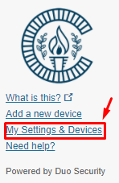
This will display the screen shown below and is where currently configured devices can be viewed, and the default device can be changed. The default behavior for authentication at login can also be selected/changed here using the dropdown menu available to the right of “When I log in”. Note: This is where you want to go to change your authentication method from what you originally chose during enrollment.
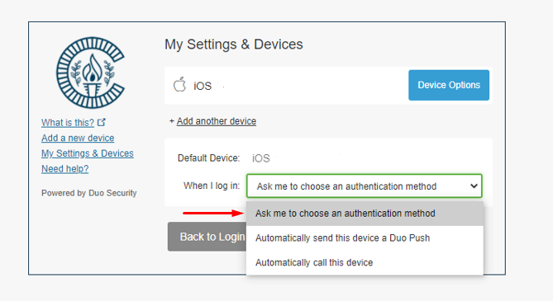
If you choose “Ask me to choose an authentication method” you will not get a prompt when logging into AnyConnect. If you enter your S# and only your password in the AnyConnect login Duo Push is the default option that will be sent to your phone.
Take a look at the “Logging into AnyConnect with Duo” document you previously received to learn more about using Duo with AnyConnect.

If the blue “Device Options” button is selected, 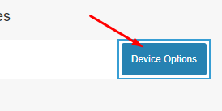another dropdown menu will appear, giving the option to reactivate Duo mobile on an existing device, to change the device name, and to delete an old device.
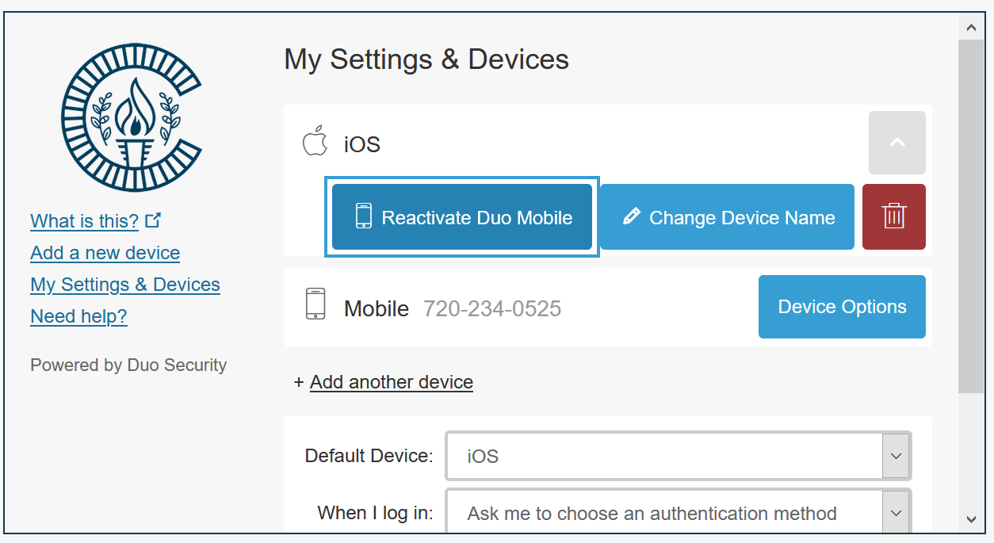
Scroll to the bottom of this window for the “Back to Login” button which returns you to the first page.

Getting Help
If you encounter any issues, or have any questions, please contact the Helpdesk for assistance.

