Logging into AnyConnect with Duo Two-Factor Authentication

Important Information
You will login to AnyConnect as you always have. Once you have entered your credentials and password and selected OK, you will get a notification on your phone. The type of notification you will be sent is dependent on the default that you chose when enrolling with Duo. (It is recommended that when enrolling that you choose “Push” as your type of notification as it is the fastest, easiest and most efficient way to login to Duo.

Logging in to AnyConnect
- Login to AnyConnect
- AnyConnect VPN does not prompt users to select how they would like to authenticate with Duo.
- AnyConnect will only prompt for a password, like so:

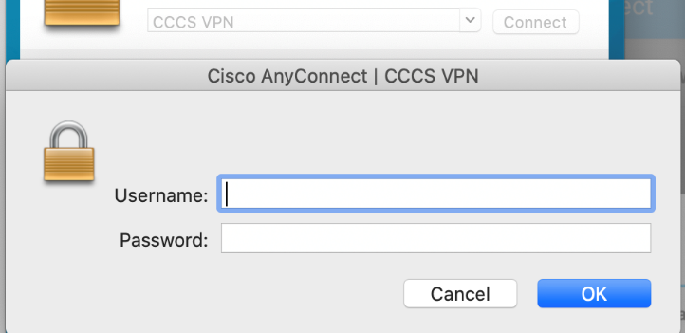

How to Authenticate with Duo
- After you submit your login information, an authentication request is automatically sent to you via push to the Duo Mobile app or as a phone call.
- However, if you wish to receive an alternative authentication method other than the default that you chose upon enrollment, you can provide the information in the password field of AnyConnect.
Note: If push/authentication request is not acknowledged, AnyConnect will lock you out. Unfortunately, AnyConnect provides no notification that lets you know that you’re locked out. The lock out will last for approximately 90 minutes unless the helpdesk is contacted to unlock the account.

Different Types of Authentication
You can add a comma (“,”) to the end of your password, followed by a Duo passcode or the name of a Duo factor. Here's how:

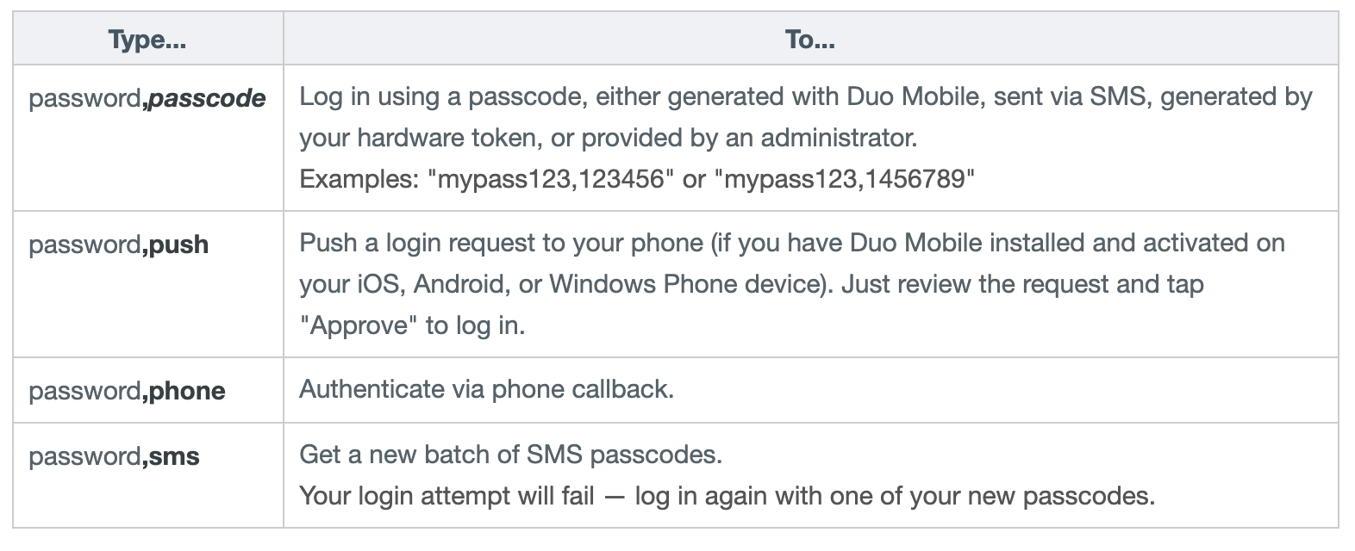
Get the Passcode from the Duo app on your smart phone and enter it along with a comma after your password.
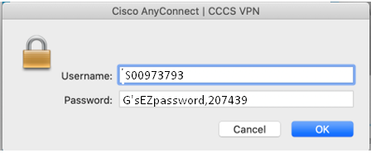

Getting Help
If you encounter any issues, or have any questions, please contact the Helpdesk for assistance.

