Logging into Outlook Web Access with Duo Two-Factor Authentication

Logging in to Outlook Web Access
You will login to Outlook Web Access (OWA) as you always have by entering your network login credentials in the format shown below.

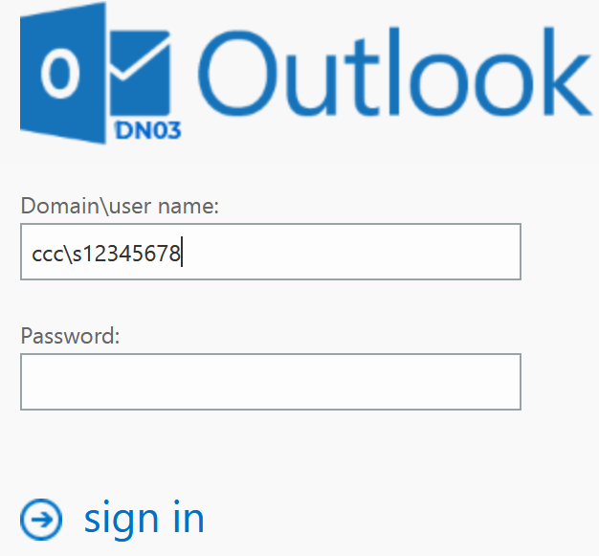

How to Authenticate with Duo
After you successfully provide your ID and password, you get the DUO MFA screen shown below.
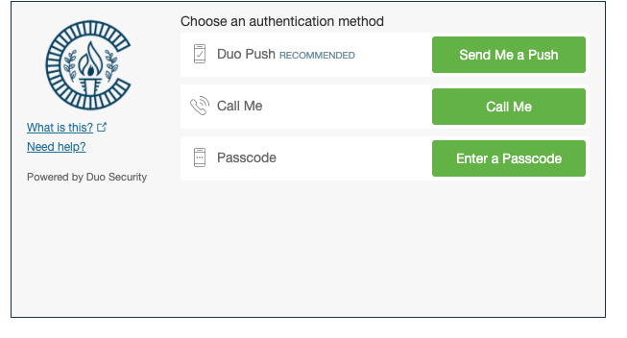
Click the green button next to your preferred authentication method.

How to Authenticate with Duo (continued)
If you select a method other than the recommended “Duo Push” method, you can expect the following behavior:
- Call me: Duo Security calls the phone number you have enrolled and requests that you press a key on your phone to authenticate.
- Enter a Passcode: The Duo MFA screen provides a space for you to enter a passcode. There you enter the passcode provided in the Duo App on your device.
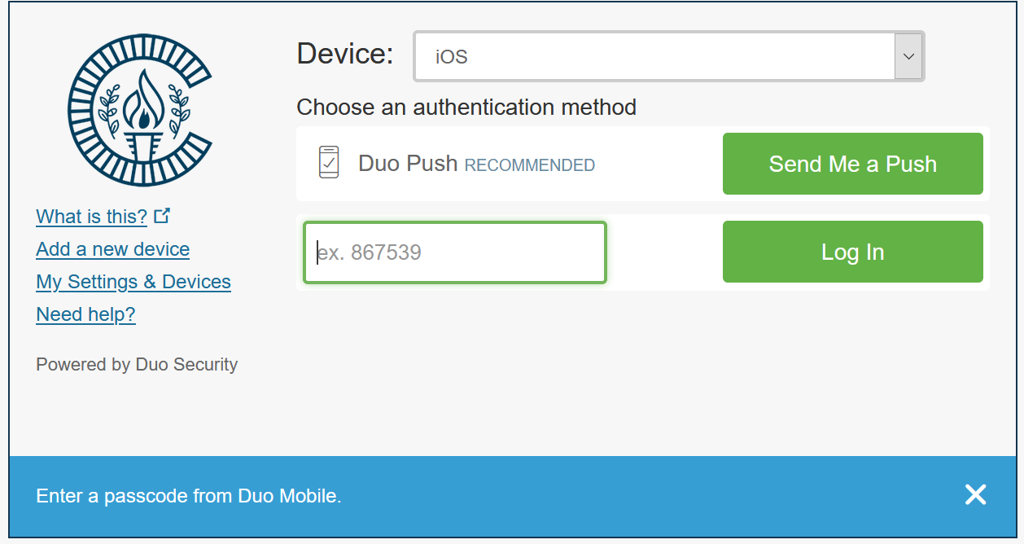
- Enter a Passcode (cont’d): For enrolled cell phones not using the Duo App, the Duo MFA screen still provides a space for you to enter a passcode, but has an added button in the blue bar to send the text to your cell phone (see sample below). This method only allows 15 seconds to enter the code received.
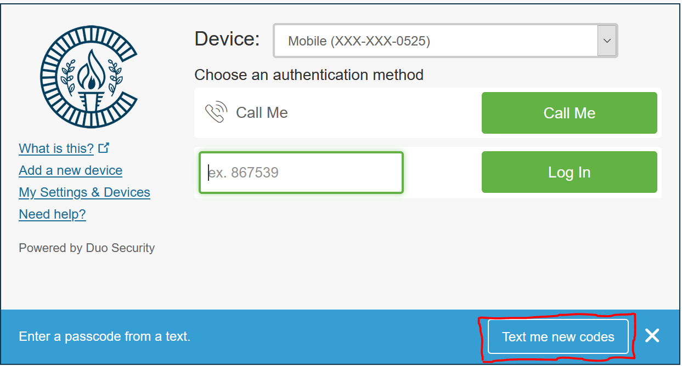
Once MFA is successful, you are logged into OWA.
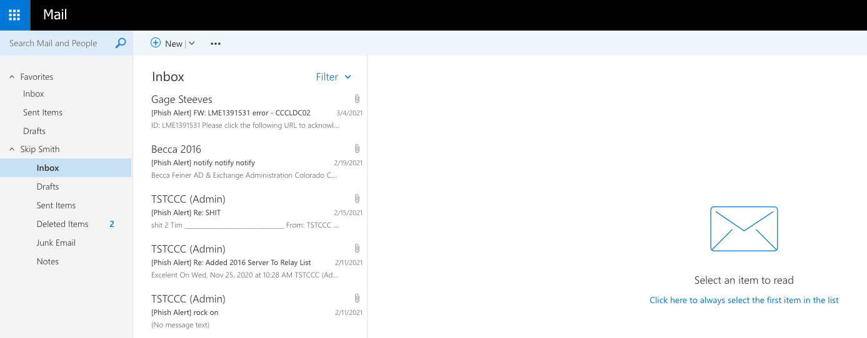
Note: If a push or call authentication request is not acknowledged, Duo Security will lock the account after 10 attempts. These attempts happen rather rapidly so, though the number of attempts may seem high, it is a relatively small time window. Lock out will last for approximately 90 minutes unless the helpdesk is contacted to unlock the account.

Getting Help
If you encounter any issues, or have any questions, please contact the Helpdesk for assistance.

