NROC Pre-Assessment Grade Service

Instructor Guide

NROC Pre-Assessment Grade Service
Instructor Guide
Getting Started
Step 1. Register Your Course
Step 2: Customize the Grade Service
Summary of Configuration Option Buttons
Reporting of Student Use
Student Help Document

Welcome to the NROC Pre-Assessment Grade Service.
This guide will assist you in making the most of your and your students' experience with the Grade Service, by helping you get started and view reports of student grades.
NOTE: This guide is based on Moodle v1.9. Your LMS interface will be different.
The Grade Service interface will be consistent with what you see here.

NOTE: Pre-assessments and course content are located in each unit, under the Unit Map link. To understand how the course works, we recommend that all instructors watch the detailed PreAssessment Webinar (accompanying PowerPoint slides are available to NROC Admin Team members at NROCnetwork.org).

Getting Started
There are two steps for instructors to get started with the Grade Service:

- Register the course with the Grade Service (create login and profile).
- Configure the Grade Service (course settings and content).

These steps are detailed below, and must be completed before students begin accessing the course. Once the Grade Service is configured, you may register students and view reports on student use.

Step 1. Register Your Course
Click the Course Configuration and Reporting link in the Introductory section of your course. Depending on your LMS, this link may be in a different location. This example is from Moodle:
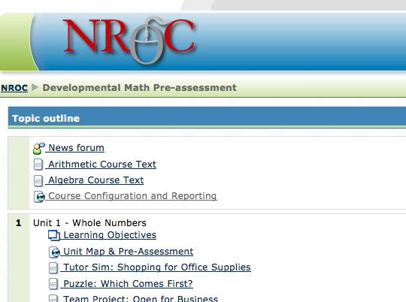

Note that the link is grayed out, indicating a “hidden” link, which students cannot see. Please do not alter this setting; it protects the privacy of student grades and the security of your instructor access.

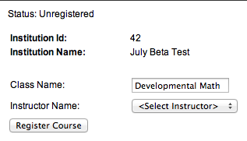
Prior to registering the course, you will see the following screen:

Confirm that the Institution Name is correct and enter a Class Name.

If you have already registered another class, your name will be in the drop down list, and you may select it now. If not, you will need to set yourself up as a new instructor.

Registering Your First Class
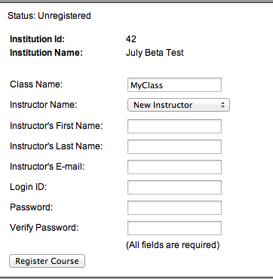
If this is the first class you have registered, select “New Instructor” from the Instructor Name drop-down list, and you will see the form fields to register as an Instructor. All fields are required.

Fill out the form, and click Register Course.

The next time you click the Course Configuration and Reporting link, you will see a screen that looks like this:

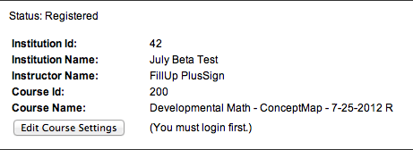

Click Edit Course Settings and enter your username and password. You will have the option to "stay logged in". This is a cookie setting, so it will only apply to the computer you are using.

If you are teaching multiple courses, you do not need to register a separate instructor name for each one. You can log in with your original username and password. The Grade Service will use the course ID to keep the records separate.

WARNING: In some browsers, the username and password may be pre-populated for you, because of a previous registration. DO NOT USE the pre-populated data. Erase them, and start with a blank field.

Step 2: Customize the Grade Service
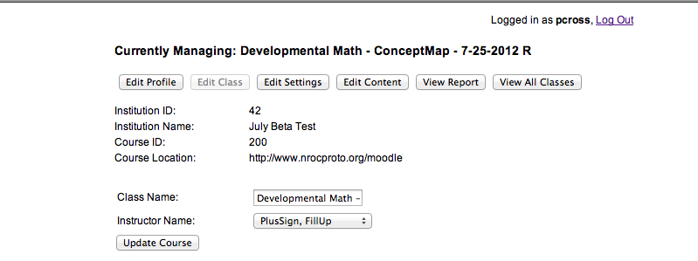
In the Moodle course, click the Course Configuration and Reporting link and sign in (if you have not already chosen to "stay logged in").

On the next screen, you will see buttons to edit your profile, settings and content. From here, you can also view reports and see all classes you have registered.

The buttons across the top of the screen will turn gray when you are on the associated page.

Summary of Configuration Option Buttons
This section will explain the purpose of each of the buttons across the top of the screen. The “View Reports” button will be explained in the next section.

Edit Profile

Change any of your profile login info.

Edit Class

Change the Class Name and/or assign it to a different Instructor. The Class Name is for your reference only, and only affects the Grade Service. It does not change the name of the class in your LMS.

Edit Settings

On the Edit Settings page, you have several options that affect how the pre-assessment is experienced by your students.

Pre-assessment Type

The pre-assessment evaluates learners on several groups of learning objectives. There are two ways this evaluation can be delivered:

Quick – In this scenario, only one question is asked for a group of earning objectives. No follow-up questions are asked if the learner selects the wrong answer.

Detailed – In this scenario, each learning objective has multiple questions. A follow-up question is asked for each objective if the learner selects selects the wrong answer. This can substantially increase the amount of time the student spends testing.

Retake Pre-assessment

Allowed – Learners can take the pre-assessment multiple times. The highest score will prevail.

Not Allowed – Learners can only take the pre-assessment once.

Mastery Score

As the instructor, you can determine the mastery score required to pass a Topic. This setting affects both the Pre-Assessment itself, and the Topic Review in the course.

Edit Content

You have the option to hide Topics and their associated Pre-Assessment questions here. Hidden Topics will not appear in the Unit Map or My Learning Path.

View Report

See next section.

View All Classes

If you have more than one class registered, you can manage them all here. You can also see your institution's Registration Key here.

Viewing Reports of Student Use
In the course, click the Course Configuration and Reporting link and sign in.

Click on View Report.
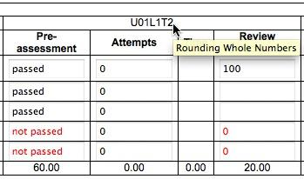
Keep in mind, as you view reports, that Topics are represented by an alphanumeric column header, which can be interpreted as follows:

Example: U01L1T2
U01 = Unit 01
L1 = Lesson 1
T2 = Topic 2

Roll your cursor over the column header to see the Topic Names.

There are three reports available to you:

Pre-Assessment Report

Select the Unit you would like to view from the drop-down.

Each row of the report contains the results for one student and all attempts if re-take is allowed (the highest scores for each Topic are kept).

You can roll over the alphanumeric column headers (e.g., U01L1T1) to see the Topic Names.

You can Delete student data. USE CAUTION: All student data will be deleted.

Unit Progress Report

Select the Unit you would like to view from the drop-down.

You can use the checkboxes to show/hide columns. Click Update Display if you have made changes.

Each row of the report contains the results for one student. The highest scores for each Topic are kept.

Roll over the alphanumeric column headers (e.g., U01L1T1) to see the Topic Names.

Scores in red are below the Mastery level (Mastery Score setting under Edit Settings).

You can edit (override) the data reported by the system. Click Edit, make changes to the data, then click Save.

Changes here will be incorporated into the other reports that use this data.

You can Delete student data. USE CAUTION: All student data will be deleted.

Class Summary Report

Use the checkboxes to show/hide columns. Click Update Display if you have made changes.

Each row of the report contains the results for one student and all attempts if re-take is allowed (the highest scores for each Topic are kept).

Roll over the alphanumeric column headers (e.g., U01L1T1) to see the Topic Names.

Scores in red are below the Mastery level (Mastery Score setting under Edit Settings).

You can Delete student data. USE CAUTION: All student data will be deleted.

Student Help Document
Learners have access to a help document while they are working in a pre-assessment. The link is in the upper right corner of the screen, and will open a new window to display the help document.
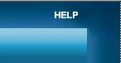

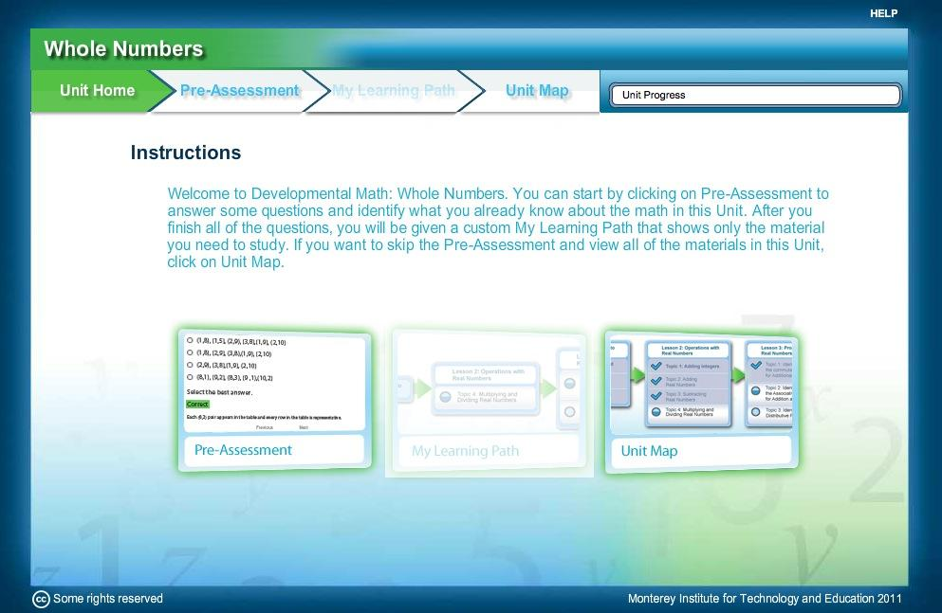

You may wish to review this document yourself, to gain a better understanding of the process from the perspective of the learner. The help document can be viewed here:
http://www.montereyinstitute.org/courses/DevelopmentalMath/U1ConceptMap/help/help.html

