Welcome to Office 365!

What is Office 365?
Office 365 is your supported cloud storage and online collaboration service.
- It provides you a place where you can securely store files, and be able to access them from almost anywhere on any device.
- It gives you the ability to easily and securely share files and folders with any one individual or with an entire group of people.
- It makes it possible for you to collaborate with others on Word, Excel, and PowerPoint documents in real time, without the need to “pass them around” in email messages and manually keep track of all of the changes.
- It gives you access to online versions of Word, Excel, PowerPoint, and OneNote making it easy to open and edit documents and notebooks, even if the device you are using does not have Office installed.
- It provides you with a FREE personal copy of Office, that you can install on up to 5 computers and 5 mobile devices for as long as you are employed at the system office.

Getting Started

Logging Into the Office 365 Portal
You can reach your Office 365 portal from any of the following locations, using ANY Internet Browser!
- Directly
  - Open any web browser, and enter the following into the address field:
  - https://portal.office.com
    - This will take you directly to the logon page.
  - If you have trouble remembering that URL, you can also go to: http://office.microsoft.com
    - Click on “Sign In” (in the upper right corner of the page)
    - Then, click on “Work, school or university”.
- From the CCCS Website
  - Scroll down to the bottom of the home page.
  - Click on “Office 365” under the Quick Links section of the page.
  - You may also find links on the Information Technology page under Faculty and Staff Resources.
- From the CCCS Connect Portal
  - Log in to the portal.
  - Click on the Employee Tab
  - Look for the Office 365 Channel, and click on “Login to Office 365” .
- Search for Office 365
  - You can use any search site, just type in “Office 365”.
  - When the search results come up, look for and click on “Sign in to Office 365”, or “Sign in to Microsoft Online Services”.
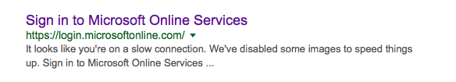
Still lost? Don’t worry, you can always contact the Help Desk at 303-620-4357 (Help). Or by email at cccs-ithelpdesk@cccs.edu.
Once you have found the login page, do the following:
- Enter your full email address in the box that says “Email or phone”.
  - firstname.lastname@cccs.edu
  - If you are unsure of what your email address is, you can look yourself up in the Global Address list in Outlook, or you can give the Help Desk a call and they can quickly look it up for you.
Note: As soon as you enter your email address and move to the password field, the page may refresh, showing you the CCCS Login page and logos. This is to reinforce that you are in the right place, and have entered a proper email address.
- In the Password field, enter the password that you use to login to your computer.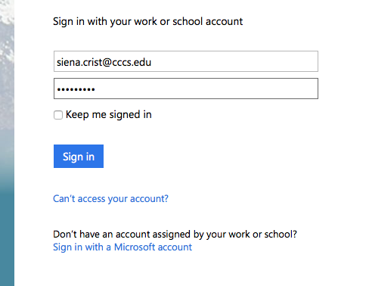

Installing Office on your Personal Devices
Once you log in to your Office 365 portal, you will be taken to your Portal Home. From here, you can launch an online application, access your OneDrive for business, or download and install Office onto your personally owned computer.
You may install Office on up to 5 personally owned computers, AND 5 personally owned mobile devices. The computers can be Mac or PC, and the mobile devices can be Apple®, Android®, or Windows®. It is currently not possible to install the applications onto a ChromeBook®, but you can still use the online versions.
Note: Do not attempt to install Office onto your work computer. Office is already installed and managed by CCCS-IT.
Note: To have the Office apps installed on your company owned mobile device, please contact the Support Desk or create a ticket to schedule a time to configure your device.
Please keep in mind that you must be an administrator on the computer that you are attempting to install Office onto.
By default, Bing will be set as your search engine, and MSN will be set as your homepage once the installation is complete. If you would like to keep that from happening, you will need to uncheck the boxes just above the “Install now” button:
If you have trouble with the download and installation, please click on the “Troubleshoot installation” link on the home page of your Office 365 portal, or contact Microsoft for assistance.
https://support.office.com/home/contact
Please do not contact the CCCS-IT Help Desk.

OneDrive for Business
OneDrive for Business is your supported cloud storage and file sharing solution. It is accessible from any computer or mobile device, with an internet connection.

Using an Internet Browser
Policy Note (excerpt from SP3-125c):
Confidential Information
All CCCS employees and associates have an obligation (and are required by law) to protect confidential information, which includes but is not limited to FERPA protected student educational records, financial aid information, and personally identifiable information. Any questions regarding what information is public and available for sharing should be referred to your supervisor who will then confer with CCCS Legal Department. The confidentiality obligation also pertains to any party accessing any communication system. Uploading or sharing of confidential data, files, documents, or information is prohibited on websites or by using programs that have not been specifically approved by CCCS.
Storage of Confidential Information
Confidential information may only be stored on secure servers owned or provided by CCCS. Confidential information shall not be stored anywhere in the cloud, unless explicitly provided or supported by CCCS, on personal computers or laptops, or any portable electronic devices.
OneDrive for Business can be quickly and easily accessed from any computer with an Internet Browser.
- Log into your Office 365 Portal using any Internet Browser.
- Click on the OneDrive tile from either the home page, or from the “Apps Launcher”.
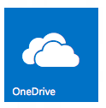

Creating files and folders
Click on the button to create new folders, Word, Excel, or PowerPoint documents using the Online Apps.

Uploading files
You can upload files into OneDrive by clicking on and dragging them from your Documents or Desktop onto the browser window. Releasing your mouse button while over the browser window will begin the upload process.
You can also upload files by clicking on the button. This will open Windows Explorer, on a PC, or Finder on a Mac allowing you to navigate to the file(s) you would like to upload.
Note: It is not possible to upload the contents of an entire folder, by attempting to upload the folder itself. Each file contained in the folder must be uploaded.
Files that you upload to OneDrive are private until you share them!

Sharing files and Folders
Files and folders that are stored on OneDrive for Business can be easily shared with others, both inside and outside of the System Office. There are many ways to share folders and individual files. Here is but one example.

To share a folder
Note: All of the contents within a shared folder are accessible to those you share it with! If you need to share a single file, do not share the folder that it is contained in. Share the file only.
- Click next to the folder to activate the checkbox selector, or click on the folder itself.
- Click on the button.
- If it is not already selected, click on “Invite People” on the left of the window that opens.
- Enter the name of the person(s) you would like to share this folder with.

Sharing Internally
- If the person(s) you are sharing with works at the System Office, you can type in their first or last name. This will search for them, and list the results just below the box.
- Clicking on the person you would like to Invite will add them to the list.
- Repeat these steps to invite additional persons to this folder.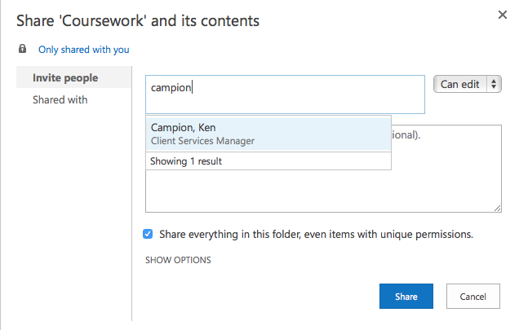

Sharing Externally
- If the person(s) you are sharing with works at any of the colleges, or outside of the Community College System, you will need to enter their complete email address here.
- OneDrive will alert you that the user you have entered is an external user.
- You will want to double check the address to make sure it is accurate! You don’t want to accidentally share with someone you don’t know!
Tip: If you are unsure of the user’s email address, and they work for one of the colleges, don’t forget you can look them up in the Global Address List inside of Outlook!
Choose whether you would like the person(s) you are sharing with to be able to edit items, or simply view them.
Once you have Saved your changes, the person(s) you have shared an item with will receive an email containing a link.
When they click on the link, they will be required to sign in with their Microsoft or Office 365 account that matches the email address that you have entered. If they do not have a Microsoft or Office 365 account, they will need to create one. Microsoft accounts are free, and can be setup using any active email address. They can sign up at www.microsoft.com/en-us/account, or when they attempt to access a shared file.

Modifying Share Permissions
To view or modify the permissions of a shared file or folder:
- Click next to the folder or file to activate the checkbox selector.
- Click on the “Share” button.
- Click on the Shared tab on the left of the share window.
- To modify the permissions, or stop sharing a file or folder with an individual, click on the Permissions for that user, and make the appropriate change.
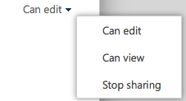

Files and Folders Shared with Me
To quickly, and easily work with files and folders that have been shared with you, simply click on the “Shared with me” link on the left side of the OneDrive window to see the list of files and folders available to you.

The Recycle Bin
To retrieve files or folders that you have deleted, simply click on the Recycle bin link on the left side of the OneDrive window (see screen shot above).
Deleted items will remain in the Recycle bin for up to 96 days.

Office Online and Training Resources
Office 365 makes available Word, Excel, PowerPoint, OneNote, and now Project from any computer with an Internet browser. This is known as Office Online.
For additional information about each of the Online products and services, including Sway, and Delve, please visit the following training resources:

Newsfeed Overview
Go to Microsoft's Support site to find out what items appear in your Newsfeed.

Sites Overview
Go to Microsoft's Support site to learn how to start using Team Sites in OneDrive for Business.

Delve Overview
Go to Microsoft's Support site to get an overview of Office Delve.

Word, Excel, and PowerPoint Online Overview
Go to Microsoft's Support site to learn how to Get Started using Office Online applications in Office 365.

OneNote Online Overview
Go to Microsoft's Support Site to learn the basics of OneNote Online.

Office Sway Overview
Go to Microsoft's Support Site to get an overview of the newly added Office Sway in Office 365.

Project Online Overview (If available)
Go to Microsoft's Support Site to Get Started using Project Online.

Help and Support
For assistance with email addresses and passwords to access your Office 365 Portal ONLY, please contact the CCCS-IT Help Desk 303-620-4357 (HELP) cccs-it-helpdesk@cccs.edu
For assistance with any of the online applications, or for additional training resources, look for the “?” in the upper right corner of the page while logged into Office 365. Click on it, and enter your question or item you would like help with.

